For Immediate Release Class Acts Arts, Inc.
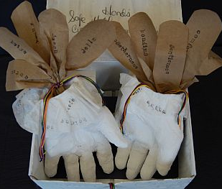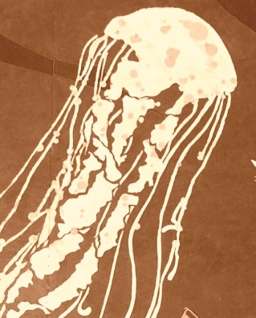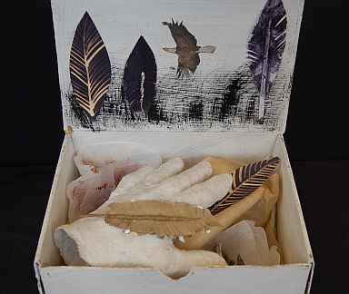
Arts-in-corrections program exhibits artwork at the Weisser Gallery
Who: Class Acts Arts, Inc. and Weisser Gallery
What: “In Our Hands” — mixed media art and paintings by inmates at the Montgomery County Correctional Facility
Where: Weisser Gallery 4080 Howard Ave # B, Kensington, MD 20895
When: Opening Reception May 11, 2012
Exhibition runs May 11 - June 13, 2012
Gallery Hours: Tues. and Wed. 11-6, Thurs. 11-8, Friday, Sat. and Sun. 10:00 - 5:00
Contact: Project Youth ArtReach (301) 613-1335
Web Site: http://classactsarts.org/project-youth-artreach
Claire@classactsarts.org, or Weisser Gallery: www.weisserglass.com (301) 571-8966

Silver Spring, April 23, 2012: Project Youth ArtReach (PYA), a program of Class Acts Arts that brings art programs to youth in correctional settings in Maryland, is partnering with Weisser Gallery and Glass Studio to exhibit artwork made during residencies by inmates at the Montgomery County Correctional Facility (MCCF) in Clarksburg, MD. The exhibition, titled “In Our Hands,” opens on May 11th from 6:00 to 8:00 pm at the Weisser Gallery, and will be on display through June 13th, 2012.
Nancy Weisser, of Weisser Glass Studios and Gallery, is generously providing the gallery space to share the work created inside the county jail under the guidance of PYA professional artists, Carien Quiroga and Peter Krsko. MCCF inmates from the women’s unit and the young men’s unit learned skills in art-making, problem-solving and team building over the course of several weeks between February and April, 2012. Sculpting with plaster and using a variety of drawing techniques, women crafted personal art pieces, each one making a statement about what it means to be accepting of their lives, their future, and all that is “in our hands.” Also featured in the exhibit are stenciled paintings made by young men at MCCF during mural arts workshops with artist Peter Krsko. These paintings are representative of a larger mural created by the young men using some of the same stencils. As with all PYA programs at the county jail and other detention centers, artists teach new skills, raise self-esteem, and encourage participants to reflect on issues of choice, accountability, and constructive means of moving forward in life
###
Project Youth ArtReach provides positive youth development programming at the Montgomery County jail in Clarksburg, the Alfred D. Noyes Children’s Center in Rockville, the Thomas J.S. Waxter Center for Girls in Laurel, and the Cheltenham Youth Facility in Prince George’s County. These programs are taught by master artists and integrate themes of respect, tolerance and conflict resolution while teaching art and life skills. Culturally-diverse arts workshops are offered in the visual, literary and performing arts. Visit http://classactsarts.org/project-youth-artreach for more info.

Montgomery County Correctional Facility (MCCF), located in Boyds Maryland (near Clarksburg), is responsible for the custody and care of male and female offenders who are either in a pre-trial status or serving sentences of up to 18 months. The facility’s average population is 750 inmates; there is a dedicated “youthful offenders” unit for men ages 21 and under. The mission of MCCF is to protect and serve the citizens of Montgomery County and the general public by providing progressive and comprehensive correctional services to all inmates. Visit http://www.montgomerycountymd.gov/doctmpl.asp?url=/content/docr/MCCF/MCCFMain.asp for more info.

Weisser Glass Studio is a complete resource center for materials and supplies, classes and workshops relating to glass art making including stained glass, fusing and kiln formed glass, mosaic, glass jewelry making, paperweight and bead making. The space features a large retail area, a gallery of contemporary glass art & exhibitions, and a large, well-equipped studio for classes. Visit www.weisserglass.com for more info.

Class Acts Arts is a non-profit 501(c)3 arts education organization that brings arts into the community through school assemblies and workshops in the performing and visual arts to children in-school, after-school, and out-of-school. We also ensure everyone has access to the arts through programs that reach low-income children, court-involved youth through Project Youth Art Reach, seniors, special needs children and adults, and wounded warriors. Visit www.classactsarts.org for more info.
Class Acts Arts is supported in part by the Arts and Humanities Council of Montgomery County, the Maryland State Arts Council, and the National Endowment for the Arts.

